GIT HUB
Q. what is GIT HUB?
GITHUB is a developer platform that allow developers to create, store and manage their code.
It uses GIT software providing the distributed of GIT plus access control, bug tracking, software feature request, task management, continuous integration
Q. Why GITHUB is very important for developer?
1. centralize code access or project access
2. easy to maintain the version of code.
How to work with GIT?
A) Installed GIT in your machine
If we want to install git in your machine you have to use the following link for download the GIT
https://git-scm.com/downloads
Note: When you install git you have to select the Launch Gitbash option
Q. What is GIT Bash?
GITBash is same like as Window power cell or it is like as terminal in Linux or mac means you manage the overall activity of git by using gitbash terminal
If we want to cross verify your GIT install successfully or not you have command git
If we want to check your gitbash location or current working directory we have command
Pwd : pwd stands for present working directory this command show us current working directory of gitbash and if we want to change the directory we have cd command shown in following screen shot
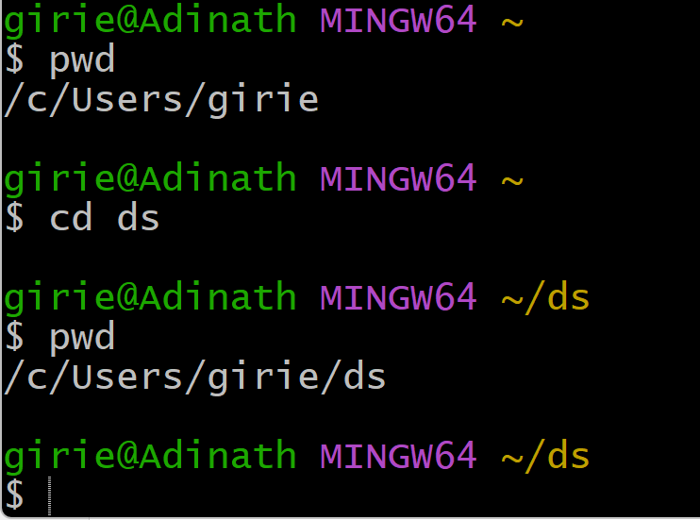
If we want to change the drive location using git bash or path using gitbash you can use following command
Syntax : cd ‘/path’

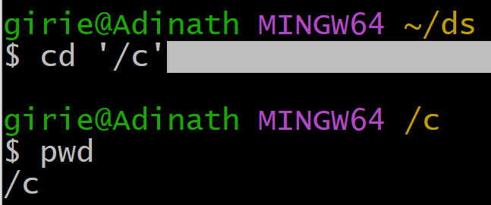
Example: cd ‘/c’ indicate we want to change drive location c or want to shift on c drive

How to Create Repository by using GIT?
Q. what is repository?
Repository means location where we store our all projects on GIT platform or on local machine also.
Steps to create repository
1. Create Folder on specified path
2. Open Git bash on folder location
3. Set up user info like as username, email etc
Q. why we need to setup user information with repository?
_______________________________________________________________________
Because single repository can access by more than one user so if we want to changes made in repository by specified user you need to set up the user info with repository means user and email address with repository
How Configure user with repository
_______________________________________________________
If we want to configure the user with repository we have following command
git config --global user.name “username”
git config –global user.email “email”
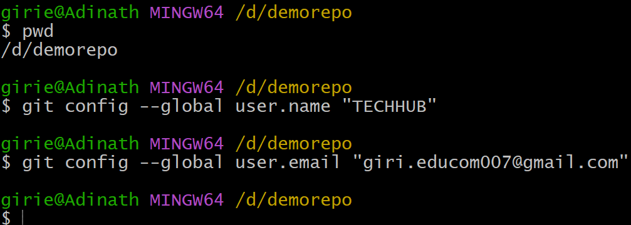

If we want to cross verify configuration information we have command
git config --list

4. Create Repository
If you want to create repository and work on repository, we need to know three stage Architecture of GIT. This architecture shows us modified file can shift in git version and save them as git repository part.
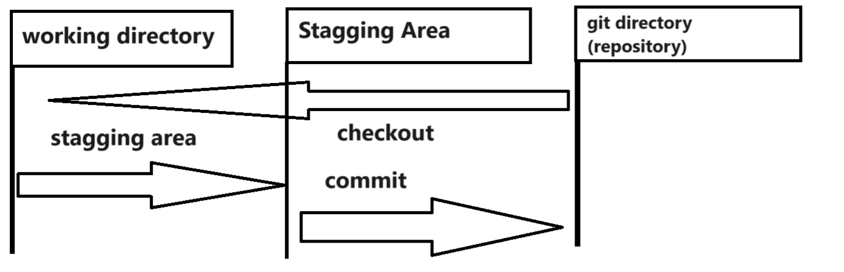

Working Directory: working directory means if you have repository and you are working on it means modify some files or add some new files in directory called as working directory
Staging Area: Stage means that you have marked as modified file in it current version to go in to your next commit or snapshot
Commit: means that the data is safely stored in your local database called as commit.
Checkout: In terms git a checkout is the act of switching between version or target entity.

git status: this command show us the status of the git repository means un stages ,stage files etc as well as show the working directory is git repository or not
if we want to convert your normal folder as git repository we have command
git init : this command help us to convert your normal folder as git repository folder.
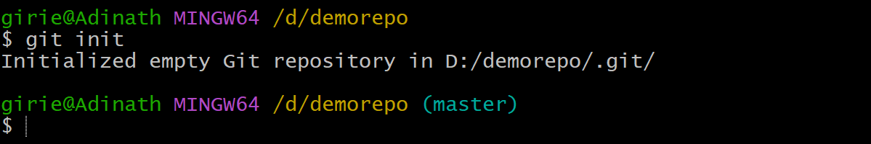
If you want to cross verify your repository is created or not successfully then we can check by using git status command shown in following screen shot
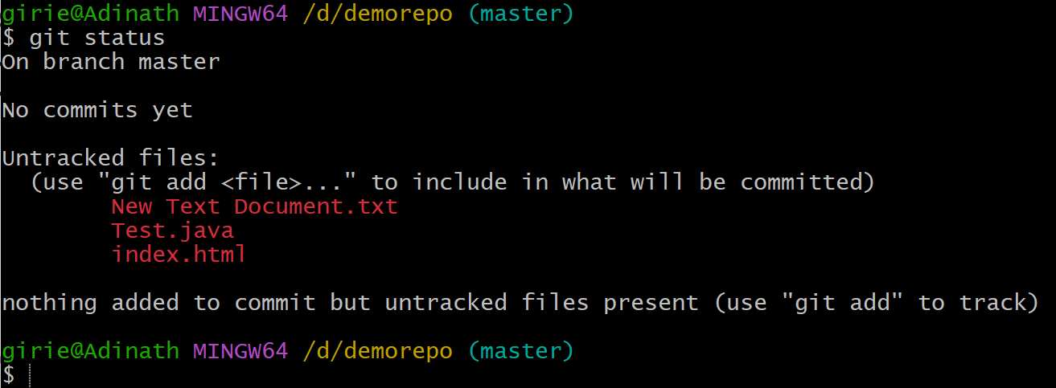
If we think about above screen shot we have statement
git status : git status this command is used for check status of your repository
on branch master : the default branch of any repository is master
Note: branching concept git we will discuss later in this series
If you get some files in red color you can consider you have modified files but you are not stage means not added as part of git repository version.
If we want to stage this file means add as part of git version or repsitory version we have command
Syntax: git add --a
Here --a means you add all files from working directory to staging area.
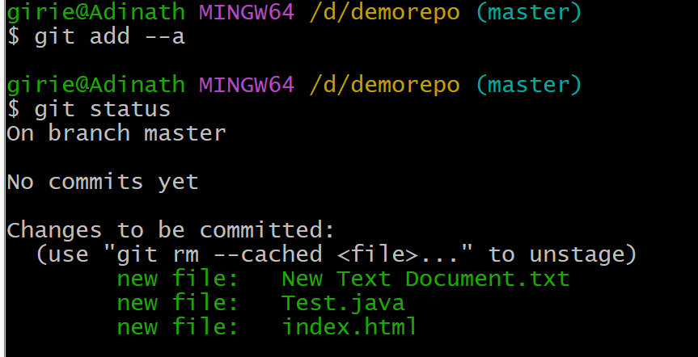
If we get some file in green colour consider your shifted your unstage files in to stage area.
After staging if you want to save this file in your git version then we have to commit it
And if we want to commit stage files we have command
git commit -m “ message with commit”;

If you check your all commits in repository we have command git log
Syntax: git log
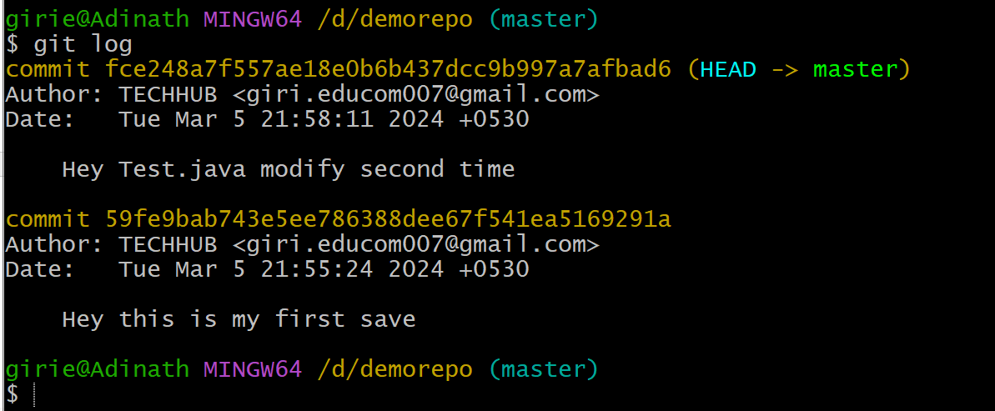

How to Create Repository on GIT website and Access on Local Machine and push data in it
1) Open github.com webiste and create your account or sign up
2) Login to Github.com
3) Create Repository
Click on create New repository button give repository name
Syntax: ownername/repositoryname
Example: //GITTECHDEMO/first
4) Create Folder on local machine and mark it as git repository by using initi command
5) Access remote repository or connect local repository with remote repository
IF we want to access remote repository on local machine you have command
git remote add origin https://github.com/GITTECHDEMO/first.git

Note: if we think about above statement remote add is command which help us add remote repository with local repository origin is name of your repository or you can change the name of repository https://github.com/GITTECHDEMO/first.git it is path of your repository which we want to connect with local machine
Once we connect your remote repository with local repository you can send data from local machine to remote repository
If we want to send the local repository code to remote repository or git repository you have to
Use the following steps.
1. execute git status command track git repsoitory
git status
2. stage your untrack files
3. Commit your stages file or commit the repository on local machine
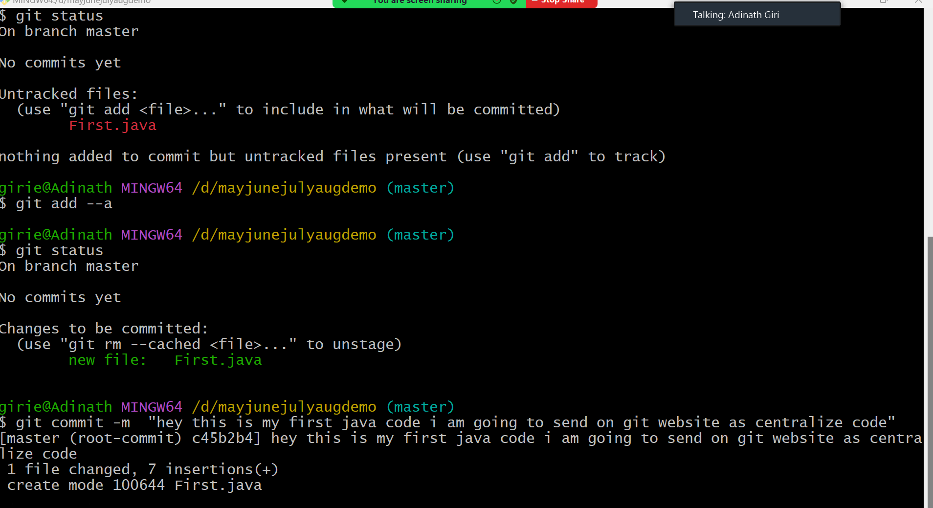
4. push the local repository code to remote repository

